PHARMACEUTICAL STANDARDIZATION OF SHATPALA GANDHAKA CHURNA
*¹Dr. T. Hema, ²Dr. Ch. Sridurga M.D. ( Ayu ), Ph.d.
*¹ PG Scholar Final year, Department of Rasa Shastra and Bhaishajya Kalpana, S.V. Ayurvedic College, TTD, Tirupati. Andhra Pradesh, India.
*² Professor and HOD, Department of Rasa Shastra and Bhaishajya Kalpana, S.V. Ayurvedic College, TTD, Tirupati. Andhra Pradesh, India.

Address For Correspondence
Dr. T. Hema,
Final year PG scholar,
Department of Rasa Shastra and Bhaishajya kalpana,
S. V. Ayurvedic College, Tirupati-517501,
Andhra Pradesh, India.
e-mail: thumbahema@gmail.com.
Phone number- 8309219527.

ABSTRACT:
Rasa oushadis are the potent Ayurvedic preparations mainly containing metals and minerals. These Oushadis possess wide range of therapeutic efficacy and are considered superior because of their qualities like small dose, quick action, palatability and longer shelf life. Shatpala Gandhaka churna is an important Rasa oushadi described in Vaidya chintamani- Kushtha prakaranam indicated for all types of Kushtha, Grahani, Gulma, Mandagni. Shatpala Gandhaka Churna contains Shuddha Gandhaka, Shuddha Bhallataka, Shuddha Chitrakamula twak, Triphala, Vidanga, Trikatu, Trijataka, Chanaka, and Jeeraka. The main pharmaceutical procedures adopted in this study are Shodhana, Churna nirmana and preparation of capsule of Shatpala Gandhaka Churna. The specific pharmaceutical blend of these contents can result in a more effective formulation. Till now, no research work has been carried out to standardize this formulation. Therefore the present study has been planned to standardize the method of preparation of Shatpala Gandhaka churna according to the method explained in the classical literature.
Keywords: Shatpala Gandhaka churna, Shodhana, Standardization.

INTRODUCTION:
The nature possesses immensely valuable and powerful medicines in the form of metals, minerals and plants. However, most of the drugs as such are not absorbable into the biological system, until and unless they undergo certain modifications. Some specialized techniques are adopted to make these drugs absorbable and therapeutically viable. The drug manufacturing processes of Ayurveda are included in discipline of Rasa Shastra and Bhaishajya Kalpana. Mineral materials as such are claimed to be toxic by Ayurvedic Rasa texts. By adopting specialized pharmaceutical procedures like Shodhana, Marana, Jarana, Murcchana etc. they are converted into nontoxic, safe and potent therapeutic forms.
Shatpala Gandhaka Churna is one of the Herbo-mineral formulation mentioned in Vaidya Chintamani,^{[1]} which contains 6 parts of Shuddha Gandhaka and 1 part each of Shuddha Bhallataka, Shuddha Chitrakamula twak, Triphala, Vidanga, Trikatu, Trijataka, Chanaka, and Jeeraka. Shodhana, Churna nirmana and preparation of capsule of Shatpala Gandhaka Churna are the main pharmaceutical procedures adopted in the preparation of Shatpala Gandhaka Churna.Standardization of Ayurvedic drugs at various levels starting from the selection and collection of raw material to the final product is essential to produce a safe and efficacious drug. Therefore in the present study an effort has been made to highlight the significance of these pharmaceutical procedures and to standardize the method of preparation of Shatpala Gandhaka Churna.

AIMS AND OBJECTIVES:
- To standardize the method of Shatpala Gandhaka Churna.
MATERIALS AND METHODS:
Collection of Raw material:
Gandhaka was obtained from Vijayawada. Triphala, Trikatu were obtained from TTD’s Sri Srinivasa Ayurvedic Pharmacy, Tirupati. Vidanga, Bhallataka, Chitrakamula twak were obtained from Chennai. Trijataka, Chanaka, Jeeraka were obtained from the local market, Tirupati.
Methods:
Entire preparation of Shatpala Gandhaka Churna was carried out in Depatment of Rasa Shastra and Bhaishajya Kalpana, TTD’s S.V. Ayurvedic College, Tirupati, Andhra Pradesh.
Shatpala Gandhaka Churna:
Reference : Vaidya Chintamani- Kushtha Roga Prakaranam
Materials : Shuddha Gandhaka -1200 g
Shuddha Bhallataka Churna – 200 g
Shuddha Chitrakamula twak – 200 g
Triphala Churna – 200 g
Vidanga Churna – 200 g
Trikatu Churna – 200 g
Trijataka Churna – 200 g
Chanaka churna – 200 g
Jeeraka churna – 200 g

Method/ Principle : Shodhana and Churna Nirmana
Apparatus : Khalwa yantra, Gas stove, Iron ladle, Steel vessel, Cloth, Spoon
Jute bag, thread, steel vessel, tray, steel cutter.

The entire pharmaceutical study was carried out in four stages:
- STAGE I
  - Shodhana of Gandhaka
  - Shodhana of Bhallataka
  - Churnodaka Nirmana
  - Shodhana of Chitrakamoolatwak

- STAGE II
- Preparation of Triphala churna
- Preparation of Vidanga churna
- Preparation of Trikatu churna
- Preparation of Trijataka churna
- Preparation of Chanaka churna
- Preparation of Jeeraka churna
- STAGE IV
Mixing of all Churna to form homogenous mixture
- STAGE V
Making capsules of Shatpala Gandhaka churna
1.Gandhaka Shodhana:
Ingredients: Ashuddha Gandhaka – 1300 g, Milk – 10 litres, Go ghrita – Quantity Sufficient
Water – As required.
Procedure:
- Milk was taken in a glass vessel. A cloth was tied to its mouth. Go ghrita was taken in laddle and melted. Gandhaka was finely powdered and added to the molten ghrita. When the Gandhaka was melted completely, it was poured into milk through the cloth.. Gandhaka was taken out from milk and washed with hot water. After washing it was kept for drying and the same process was repeated for six more times (total 7 times). Fresh milk was taken each time.
Observations:
- On complete melting, Gandhaka changed into ghee like liquid.
- After Shodhana, Gandhaka colour was changed from dull yellow to thick, bright yellow colour with increased luster.
2. Bhallataka Shodhana:
Ingredients: Asuddha Bhallataka-5oo g
Procedure:
Bhallataka ripe seeds were taken and put in to water. Only those which sink were selected and used for the purification and rest were discarded. The upper cap like structure was removed with the help of steel cutter. The nuts were kept in a jute bag containing brick powder. Then jute bag was tied and rubbed until the irritant oil was absorbed by the brick powder. Then the seeds were washed thoroughly with hot water. Then it was dried in sunlight. After drying it was made into fine powder.

Observations:
- Bhallataka seeds were converted into small pieces.
- The jute bag taken was slightly wet with Bhallataka taila.
- Change in color of brick powder due to the absorption of Bhallataka taila.
3. Churnodaka Nirmana:
Ingredients: Sudha churna-1g, Water - 240 ml
Procedure:
- 1 g of Sudha churna was taken in a vessel and added with 240ml of water, mixed thoroughly and left for 12 hours. Later, the supernatant water was taken out and filtered through filter paper and Churnodaka was obtained.
Obesrvations:
- Churnodaka - colourless liquid (similar to water) was collected.
4. Chitrakamoola twak Shodhana:
Ingredients: Chitrakamoola twak-300g, Churnodaka- As required
Procedure:
- Chitrakamoola twak was cleaned to remove external impurities if any. Chitrakamoola twak was taken in khalwa yantra and pounded. It was soaked in Churnodaka for one day and dried in sunlight.
Observations:
- Colour of the Churnodaka turned to orange colour.
5.Triphala Churna Nirmana:
Ingredients: Amalaki-100g, Haritaki-100g , Vibhitaki-100g
Procedure:
- Amalaki,Haritaki,Vibhitaki were taken in equal quantities. Then these three drugs were taken separately in Khalwa yantra and made into powder and filtered through a cloth to get fine powder and mixed together.
Observations:
- Triphala churna obtained was very fine.
6.Vidanga churna Nirmana:
Ingredients: Vidanga-500 g
Procedure:
- Vidanga was checked for any external impurities, worms and insects and cleaned. Then it was subjected for powdering in Hammer crusher. Powder obtained from hammer crusher was shifted to Swifter machine for getting very fine powder of Vidanga. Vidanga powder obtained was kept in air tight jar.
Observation:
- Very fine powder of Vidanga was obtained.
7. Trikatu churna Nirmana:
Ingredients: Shunti-100g, Pippali-100g, Maricha-100g.
Procedure:
- Dried Shunti, Maricha and Pippali were collected. Then these drugs were grinded in a Pulverizer and made into powder separately. Then these three powders were sieved through swifter sieve separately and mixed together.
Observations:
- Trikatu churna obtained was very fine.
8. Trijataka Churna Nirmana:
Ingredients: Twak - 200g, Ela- 200 g, Patra- 200g.
Procedure:
- Twak, Ela and Patra churna were taken in equal quantities in a Khalwa yantra and mixed well to form a homogenous mixture.
Observations:
- Trijataka churna was obtained.
9. Chanaka Churna Nirmana:
Ingredients: Chanaka–300 g
Procedure:
- Dried Chanaka was checked for any external impurities, worms and insects and cleaned. It was taken in Khalwa yantra and pounded. Pounded material was sieved through a cloth to obtain very fine powder.
Observations:
- Chanaka churna obtained was light yellowish in colour.
10. Jeeraka churna Nirmana:
Ingredients: Jeeraka- 300g
Procedure:
- Jeeraka was cleaned to remove external impurities if any. It was pounded in Khalva yantra and filtered through a cloth to obtain fine powder.

Observations:
- Jeeraka churna obtained was very fine.
11. Preparation of Homogenous mixture:
Ingredients: Shuddha Gandhaka -1200 g
Shuddha Bhallataka Churna – 200 g
Suddha Chitrakamula twak – 200 g
Triphala Churna – 200 g
Vidanga Churna – 200 g
Trikatu Churna – 200 g
Trijataka Churna – 200 g
Chanaka churna – 200 g
Jeeraka churna – 200 g
Procedure:
- Fine churna obtained after practical No. 1,2,4,5,6,7,11, 12,13 were added one by one in Khalwa yantra and mixed well. Mixing was carried out till a homogenous mixture was obtained. It was collected and preserved in an air tight glass container.
Observations:
- Very fine homogenous mixture was obtained.
12. Preparation of capsules of Shatpala Gandhaka Churna:
Ingredients: Homogenous mixture of Shatpala Gandhaka Churna- 2790 g
Procedure:
- Capsules of uniform size were taken. 500 mg of Shatpala Gandhaka Churna was filled in each capsule and weighed. Capsules were preserved in absolute sterile and moisture free glass containers.
Observations:
- On average, one among every 100 capsules was damaged.

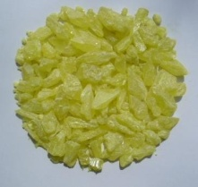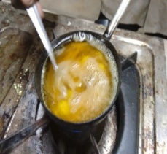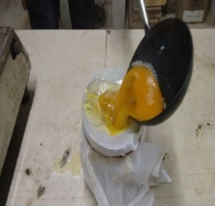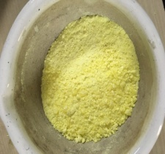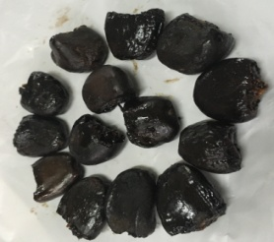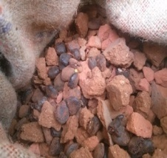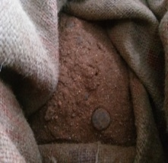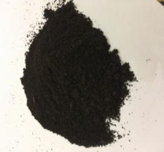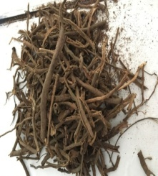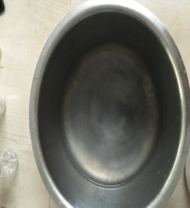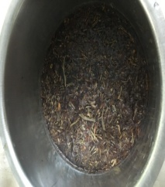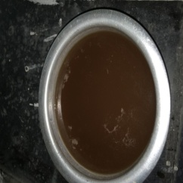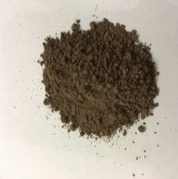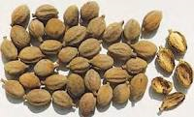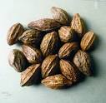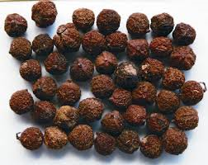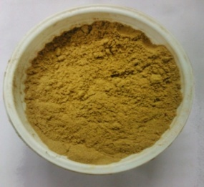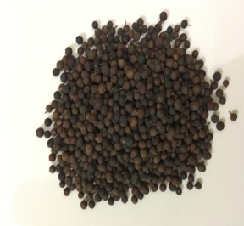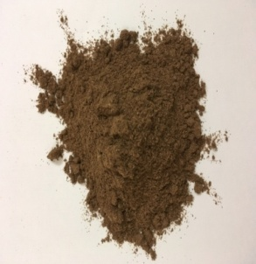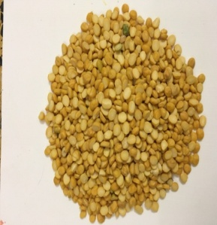
20
18
17
15
14
13
3
9
12
11
8
7

4
2
1
6
5
IMAGES SHOWING THE PREPARATION OF SHATPALA GANDHAKA CHURNA:

21
19
16
10
1-Gandhaka before shodhana
2-Melting Gandhaka
3-Pouring molten Gandhaka into milk
4-Shoditha Gandhaka
5-Cutting cap like structure of Bhallataka seeds
6-Bhallataka seeds mixed with Istika Churna
7-Bhallataka seeds after rubbing vigorously in a jute bag
8-Shoditha Bhallataka churna
9-Chitraka moola twak
10- Churnodaka
11-Soaking Chitraka moola twak in churnodaka
12-Churnodaka turned in to orange color
13-Chitraka moola dried in sunlight
14-Shoditha chitraka moola twak churna
15-Harithaki
16-Vibhitaki
17-Amalaki
18-Triphala churna
19-Vidanga
20-Vidanga churna
21-Chanaka

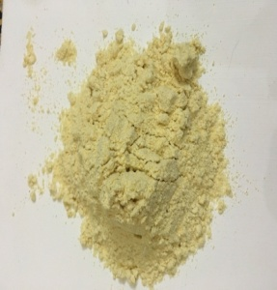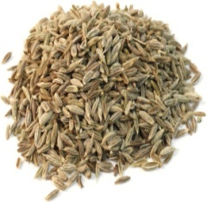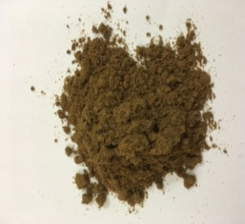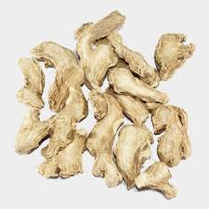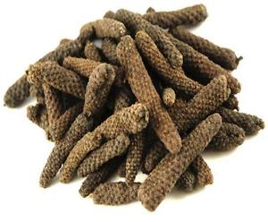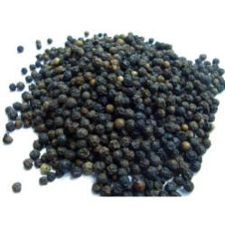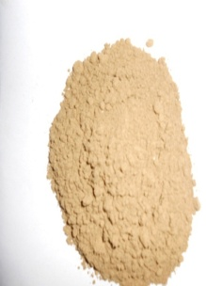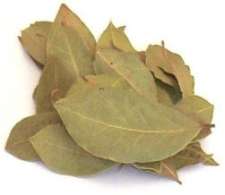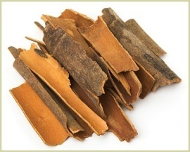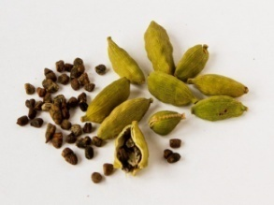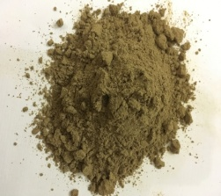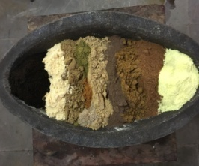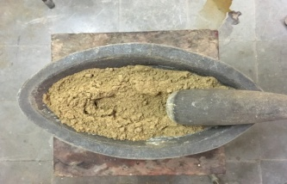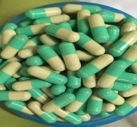
34
31
33
32
35
29
28
30
27
26
25
22
23
24

22- Chanaka churna
23- Jeerka
24-Jeeraka churna
25-Sunthi
26-Pippali
27-Maricha
28-Trikatu churna
29-Twak
30-Ela
31-Patra
32-Trijataka churna
33-Mixing of Gandhaka and herbal drugs
34-Homogenous mixture of Shatpala Gandhaka churna
35- Capsules of Shatphala Gandhaka churna

Results:
Table No. 1: Showing the result of Gandhaka Shodhana
S.no | Initial weight | Final weight | Loss in weight | Loss in percentage
1. | 1300 g | 1270 g | 30g | 2.3%

Table No. 2 : Showing the Result of Bhallataka Shodhana
Initial Weight | Final Weight | Loss in Weight | Loss in percentage
500 g | 260 g | 240 g | 48%

Table No. 3 : Showing the Result of Churnodaka Nirmana
Ingredients | Quantity taken | Quantity of churnodaka obtained
Sudha Churna | 1g | 230ml
Water | 240ml

Table No. 4 : Showing the Result of Chitrakamoola twak Shodhana
Weight of Chitrakamoola twak | Weight after Shodhana | Loss in weight | Loss in percentage
300g | 298g | 2g | 0.66%

Table No.5 : Showing the Result of Triphala Churna Nirmana
Weight Of drug taken | Final wt. | Loss in wt | Loss in percentage
Amalaki-100g  Haritaki-100g  Vibitaki-100g | Triphala churna-280g | 20g | 6.6%

Table No.6: Showing the result of Vidanga churna nirmana:
Initial weight | Final weight | Loss in weight | Loss in percentage
500 g | 490g | 10g | 2%

Table No.7: Showing the result of Trikatu churna nirmana

Initial Weight | Final Weight | Loss in Weight | Loss in percentage
Shunti- 100g  Pippali- 100g Maricha- 100g | Trikatu churna – 270 g | 30 g | 10%

Table No. 8 : Showing the Result of Trijataka Churna nirmana
Initial weight | Final Weight | Loss in Weight | Loss in percentage
Twak churna- 200g  Ela churna- 200g  Patra churna- 200g | Trijataka churna– 595g | 5g | 0.83%
Table No. 9 : Showing the Result of Chanaka Churna Nirmana
Weight of Chanaka taken | Weight of Chanaka churna obtained | Loss in weight | Loss in percentage
300g | 295g | 5g | 1.66%

Table No. 10 : Showing the result of preparation of Jeeraka Churna:
Initial Weight | Final Weight | Loss in weight | Loss in percentage
300g | 280 g | 20g | 6.6%
Table No.11 : Showing the result of mixing of component drugs of Shatpala Gandaka Churna.
Initial Weight | Final Weight | Loss in Weight | Loss in percentage
2800 g | 2790 g | 10 g | 0.35%

Table No.16: Showing the result of Preparation of capsules of Shatpala Gandhaka Churna.
Weight of Shatpala Gandhaka Churna | No. of Total Capsules  (Each 500 mg) | No. of spoiled capsules
2790g | 5570 Capsules | 55

DISCUSSION:
Most of the materials of Rasa Shastra are obtained from mineral sources containing various impurities which are responsible for causing toxic effects to body tissues. Therefore as a rule the Rasa dravyas are purified first by a specialized processing technique known as Shodhana before subjecting them for the main processing. It is done to remove visible & invisible impurities, to reduce the toxicity and to enhance the therapeutic property.

Gandhaka shodhana:
Gandhaka Shodhana was done according to the method that was mentioned in Rasa Ratna Samucchaya^{[2]}, which includes melting of Gandhaka in ghee and pouring into a vessel filled with milk through fine cloth. Gandhaka is highly Pitta vardhaka^{[3]}. Both ghee and milk are Vata Pitta shamaka dravyas^{[4]} and among them ghee is the drug of choice among fats in reducing Pitta. Therefore, these can reduce ‘teevra pitta vruddhikara’ effect of Gandhaka. Milk and Ghee are Vishahara and Rasayana. These can remove Visha doshas of Gandhaka and impregnate Rasayana property to Gandhaka.Final cleaning with hot water removes greasy remnants of milk and ghee.
Churnodaka Nirmana :
Churnodaka Nirmana was done according to the method that was mentioned in Rasatarangini.^{[5]} 1g of Sudha churna was taken in a vessel and added with 240ml of water, mixed thoroughly and left for 12 hours. Later, the supernatant water was taken out and filtered through filter paper and Churnodaka was obtained.
Chitrakamula twak Shodhana:
Chitrakamula twak Shodhana, was done according to the method that was mentioned in Rasatarangini.^{[6]} Chitrakamoola twak was cleaned to remove external impurities if any.Chitrakamoola twak was taken in khalwa yantra and pounded. It was soaked in Churnodaka for one day and dried in sunlight. Colour of the Churnodaka turned to orange colour. Shodhana reduces the teekshnatva of Chitrakmoola.
Bhallataka Shodhana:
Bhallataka Shodhana was done according to the reference Rasa tarangini.^{[7]} Bhallataka seeds are rubbed with Istika churna in a jute bag. In Ayurvedic literature, the synonym Shopha hetu, Spota hetu, agnika are given to this drug based on its blister causing nature. ^{[8]} The oil in the fruit is responsible for the irritation. ^{[9]} The fruit contains tarry oil which causes contact dermatitis. Medically it is named as Urushiol Induced Contact Dermatitis because the chemical Urushiol is responsible for the dermatitis. This vesicant nature is removed while doing Shodhana with Istika churna. The oil in the fruit is responsible for the irritation.The Bhallataka fruit contains 90% Anacardic acid and 10% of Cardol. Other chemical constituents are bhilawanol ^{[10]}, semecarpol ^{[11]} and anacordol ^{[12]}. Recent studies reported that bhilawanols are known as urushiols. Anacardic acids are closely related to urushiol. Another study reported that the corrosive juice from the pericarp of the fruit is found to contain catechol, fixed oil and anacardol (C₁₈H₁₃O₃.COOH) to which the corrosive properties of the juice are due to two phenolic acids C₁₆H₁₅O_{3.}COOH and C₁₄H₁₃O₃.COOH^{[13]} . Brick powder is having adsorbant property so corrosive oil present in the fruit is absorbed by the brick powder.
Churna nirmana of herbal drugs:
Shuddha Bhallataka, Shuddha Chitrakamulatwak, Triphala, Vidanga, Trikatu, Trijataka, Chanaka, Jeeraka were made into fine powder, according to the Churna kalpana reference mentioned in Sharangadhara Samhita Madhyama Khanda^{[14]}.
Preparation of homogenous mixture of all component drugs :
Gandhaka obtained after shodhana and the fine powders of herbal drugs were mixed in the ratio as mentioned in the reference sloka to obtain the homogenous mixture of Shatpala Gandhaka Churna.
Preparation of Shatpala Gandhaka Churna Capsules:
Capsules of uniform size were taken.500 mg of Shatpala Gandhaka Churna was filled in each capsule and weighed. Capsules were preserved in absolute sterile and moisture free glass containers. Capsule form was selected keeping in view of ingredients like Twak, Ela and Patra, which contain volatile oils, which may lose their potency on making tablets. Hence, Shatpala Gandhaka Churna was given in the form of capsules to the patients in the prescribed dose.
CONCLUSION:
Pharmaceutical standardization of Rasa oushadis is an important requisite for the establishment of their efficacy and consistent biological activity. The pharmaceutical procedures involved in this is study are Shodhana, Churna nirmana and Preparation of capsules of Shatpala Gandhaka Churna. Shodhana plays a vital role by removing the toxic nature and improving the therapeutic efficacy , there by rendering a safe and effective formulation.

REFERENCES:
1. Dr. K. Rama Chandra Reddy. Vaidya chintamani Vol. II ( Sula prakaranam to Parinama prakaranam ) 1st edition; Golghar, Varanasi; Chaukamabha Orientalia; 2014. P. 400.
2. Dr. Indradev Tripati. Rasa Ratna samucchaya; Edition :Reprint-2013; Golghar, Varanasi; Chaukambha Sanskrit Sansthan;P.28.
3. Acarya Sri Madhava, Ayurveda Prakasha, edited with the Arthavidyotani and Arthaprakasini Sanskrit and Hindi commentaries by Shri Gulraj Sharma Mishra, Chaukhambha Bharati Academy, Varanasi, reprint edition 2014. P. 259.
4. K. R. Srikantha Murthy, Bhava prakasha of Bhavamisra; English Translation; Vol-1; Varanasi; Chaukambha Krishnadas Academy, reprint edition 2011. P. 454 and 470.
5. Pandit Kaseenatha Sastrina; Rasa Tarangini; 11th edition; Chouka, Varanasi; Mothilala Banarasidasa; P.280
6.Pandit Kaseenatha Sastrina; Rasa Tarangini; 11th edition; Chouka, Varanasi; Mothilala Banarasidasa; P.753
7. Pandit Kaseenatha Sastrina; Rasa Tarangini; 11th edition; Chouka, Varanasi; Mothilala Banarasidasa; P.735
8. Bapalal G Vaidya; Nighantu Adarsha; Vol.1.1st edition; Varanasi: Chaukhamba Bharati Academy; 2007.p.31
9. Govindhan;Chief editor Dr. C. R. Agnivesh, Editors- Dr. P. Unnikrishnan, Dr. George M.J. Vishavaidya Jyotsnika-An English Translation. 1st edition; Department of Agadatantra ;Vaidyaratnam P. S. Varier Ayurveda College, Kottakal. 2002. P. 200-201.
10. Naidu, D.S. 1925. Constituents of the marking-nut: Semecarpus anacardium Linn. Journal of Indian Institute of Science 8: 129–14
11. C.P. Khare, editor. Indian Medicinal Plants- An illustrated Dictionary; Springer science; 1st edition; New Delhi, India; Private Limited; 2007.p.597.
12. Nagabhushanaa, K.S, Umamaheshwari, S.,Tocolic F.E., Prabhu S.K., Green, I.R. and Ramadoss C. S. Inhibition of soybean and potato Lipoxygenases by Bhilawanols from Bhilawan (Semecarpus anacardium) nut shell liquid and some synthetic Salicylic acid analogues. Journal Enzyme Inhib. Medical Chemistry 2002; 17(4): 255–259.
13. Naidu D.S. Constituents of the marking-nut:SemecarpusanacardiumLinn. Journal of Indian Institute of Science 1925; 8:129– 142.
14. Pandit Dwarakanath Misra Sastri; Sharangadhara Samhitha Madhyama Khanda-1st edition; Golghar, Varanasi; Chaukambha Krishnadas Academy; 2010. P. 280.

