Figure 1 oedema after carrageenan injection

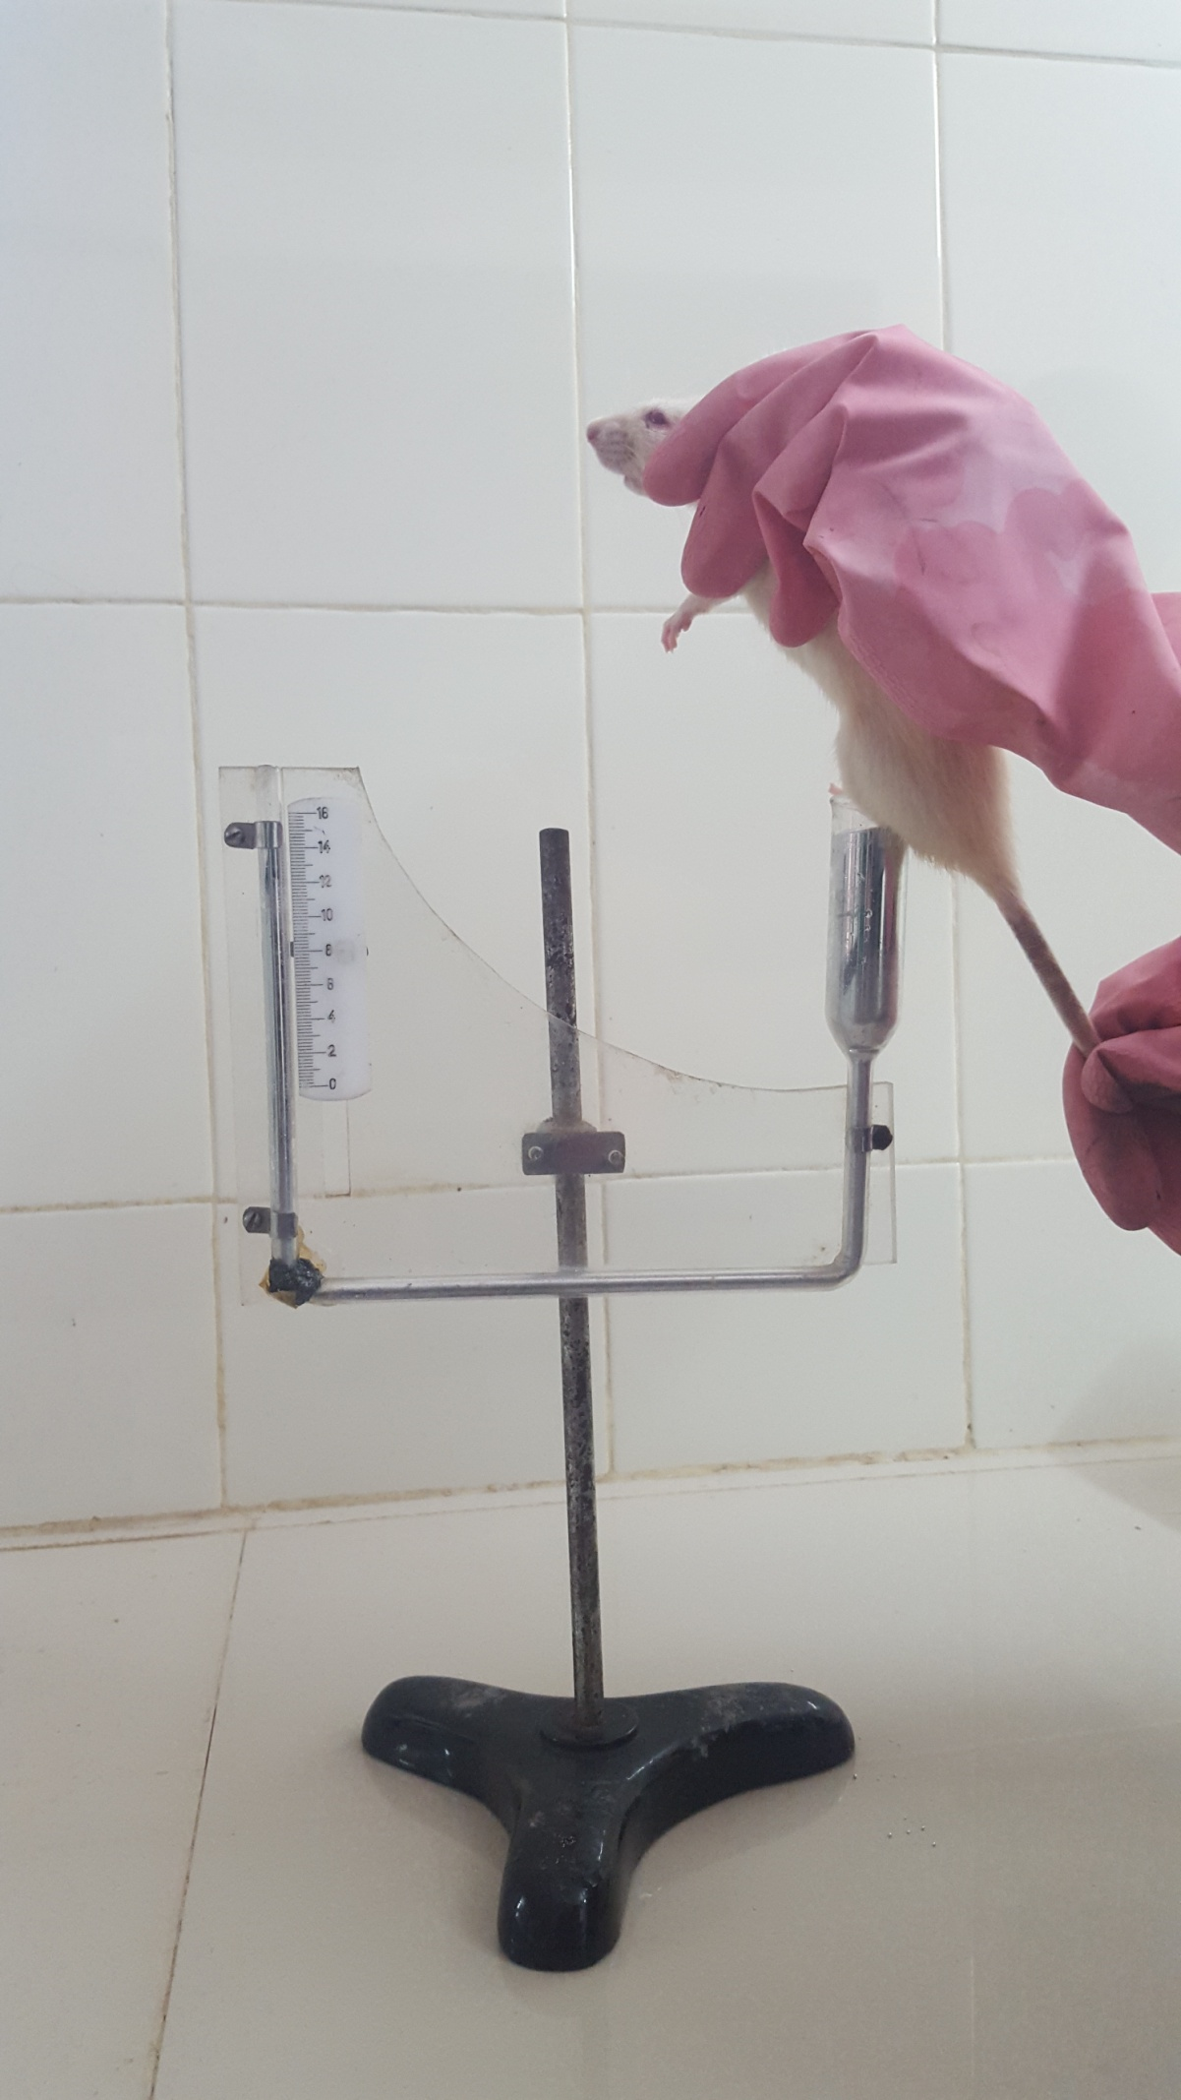
Figure 2 measurement of pawvolume using Plethismometer

